LINUX COMMAND LINE
189587 Yona Abuya
182174 Hope Mbugua
192229 Mary Easter
191239 Keane Mbae
193362 Mulle Emmanuel
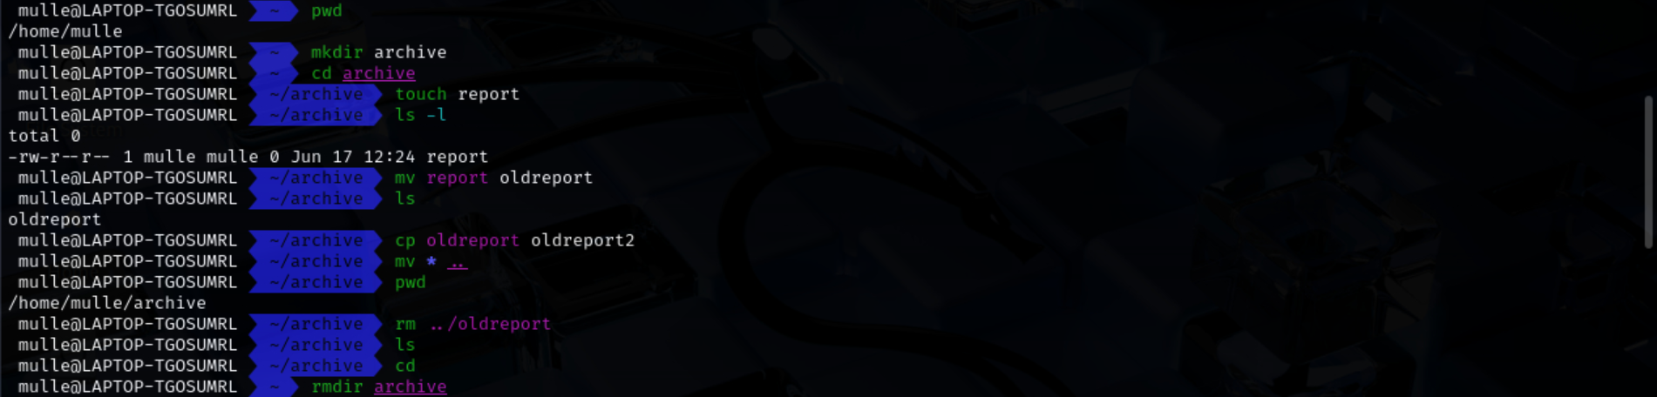
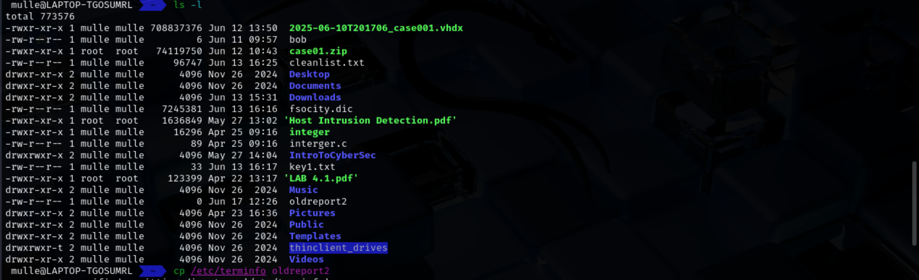
PROJECT 4-1
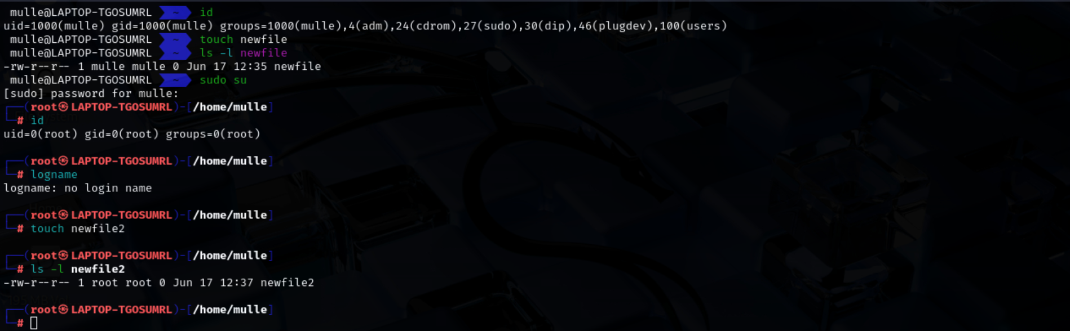
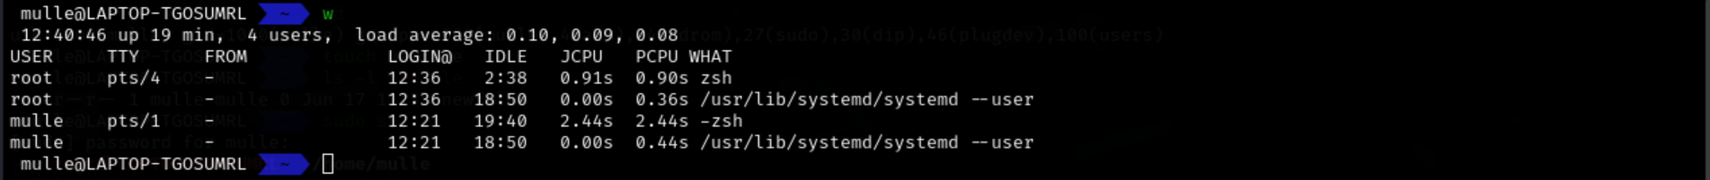
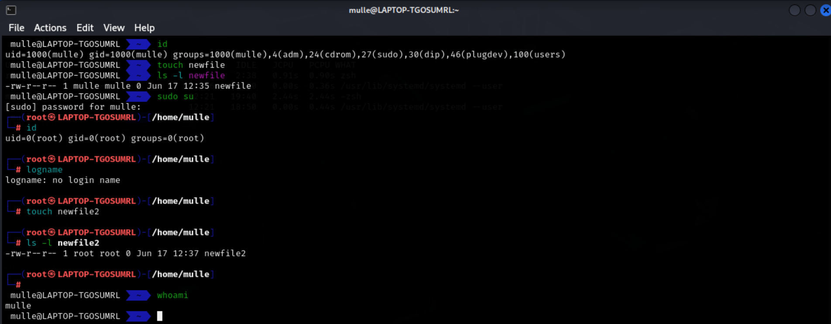
PROJECT 4-2
